**A Project Report**

*on*

**Evolutionary Computing and Quantum Optimization Initiated MRI Image-based Alzheimer’s Detection**

*carried out as part of the* ***Minor Project IT3270*** *Submitted*

by

**Arshiya Zakir Hussain**

**209302196**

*in partial fulfilment for the award of the degree* *of*

**Bachelor of Technology**

in

**Information Technology**

Under the Guidance of

**Guide Name**

**School of Information Technology**

**Department of Information Technology**



**MANIPAL UNIVERSITY JAIPUR**

**RAJASTHAN, INDIA**

**April 2023**

**CERTIFICATE**

Date:21/4/23

This is to certify that the minor project titled **Evolutionary Computing and Quantum Optimization initiated MRI based Alzheimer’s Detection** is a record of the Bonafide work done by **Arshiya Zakri Hussain** (209302196) submitted in partial fulfilment of the requirements for the award of the Degree of Bachelor of Technology in Information Technologyof Manipal University Jaipur, during the academic year 2022-23.

**Mr. Venkatesh Gauri Shanker**

*Senior Professor*

*Project Guide, Department of Information Technology*

*Manipal University Jaipur*

**Dr. Pankaj Vyas**

*HoD, Department of Information Technology*

*Manipal University Jaipur*

**ABSTRACT**

Alzheimer's is a serious neurological disorder and one of the most prevalent health conditions worldwide. The early diagnosis of the disease is important in controlling its progression; however, the early diagnosis is difficult. Through deep learning and advanced techniques like evolutionary computing which deals with genetic algorithms the task of early detection can be simplified relatively. The project idea is to develop a machine-learning model which could detect the early symptoms of Alzheimer's using MRI images. The optimization part would be covered in Evolutionary computing and Quantum optimization. The work uses genetic algorithms and patient data in the diagnosis and monitoring of Alzheimer's disease. The aim is to develop a novel system for the diagnosis of Alzheimer's by utilizing genetic programming as data-driven evolutionary computation-based modeling. The optimization algorithms had been used to get near-optimum solutions for large-scale optimization problems and the effectiveness is measured in terms of the number of iterations, number of features, and application ease. For the very general outline of the work that is to be done, MRI images will be fed to the trained model using methods of evolutionary computing and machine learning and through best-suited optimization techniques, accurate results will be presented.

Methodology adopted for the project includes data selection and data preprocessing using

Methods like image enhancement, segmentation etc. followed by model selection and implementation followed by optimization techniques of genetic algorithm blended with

Quantum optimization

The Models trained for the above purpose are U-NET, VGG-19, and DENSE-NET, QCNN (Quantum Convolution Neural Network)

* Results obtained from U-NET model are: 65% training accuracy and 59% training loss
* Results obtained from VGG-19 model are: 70% training accuracy, 87% training loss, 22%
* Validation accuracy
* Results obtained from DENSE-NET model are training accuracy 50%, validation accuracy 49%

For QCNN- quantum convolution neural network the results have not been deduced yet

Other optimization models to be used are NQO (Nero quantum optimization) and QPSO (quantum swarm optimization)

**LIST OF TABLES**

|  |  |  |
| --- | --- | --- |
| **Table No** | **Table Title** | **Page No** |
|  |  |  |
| 1. | Result of U-NET model | 11 |
| 2. | Result of VGG-19 model | 12 |
| 3. | Result of DENSE-NET model | 12 |

**LIST OF FIGURES**

|  |  |  |
| --- | --- | --- |
| **Figure No** | **Figure Title** | **Page No** |
|  |  |  |
| a | U-NET Architecture | 8 |
| b | VGG-19 Architecture | 9 |
| c | Dense-Net Architecture | 9 |
| 4.2.a1 | Training accuracy | 11 |
| 4.2.a2 | Training loss | 11 |
| 4.2.b1 | Training and validation accuracy | 12 |
| 4.2.b2 | Training and validation loss | 12 |
| 4.2.b3 | Classification matrix | 12 |
| 4.2.c1 | Training and validation accuracy | 13 |
| 4.2.c2 | Training and validation loss | 13 |

Table of Contents

**Introduction1**

1.1 Introduction2

1.2Problem Statement3

1.3 Objectives4

1.4 Scope of Project5

**Background Detail6**

2.1 Literature Review7

2.2Other Software Engineering Methodology8

**System Design & Methodology9**

3.1 System Architecture10

3.2Development Environment11

3.3Methodology12

**Implementation & Result13**

4.1 Implementation Detail14

4.2 Results and Discussion15

4.3Month Wise plan of work16

**Conclusion & Future Plan17**

5.1 conclusion18

5.2 future plan19

**INTRODUCTION**

* 1. *introduction*

Alzheimer's is a serious neurological disorder and one of the most prevalent health conditions worldwide. The early diagnosis of the disease is important in controlling its progression; however, the early diagnosis is difficult. Through deep learning and advanced techniques like evolutionary computing which deals with genetic algorithms the task of early detection can be simplified relatively.

The main work mostly would be to do an accurate classification of patients with Alzheimer's and the patients who are healthy. This also involves feature selection, as some of the features might be irrelevant or redundant. On the other hand, using all the features might reduce the effectiveness of the classification. Studies show machine learning models and neural networks show phenomenal potential in making the task at hand effective and accurate.

The aim is to reduce processing time and improve the performance of the solutions and for the same improved genetic algorithms would be introduced depending on different natural processes. The algorithms will be defined as optimized if they cover three out of many factors considered for optimization ability i.e., being simple in concept, easy to implement, and computationally efficient. The outline of the work sketches working with ADNI (Alzheimer s Disease Neuroimaging Initiative) datasets and MRI images of the brain and then selecting and developing machine learning models that can perform the underlined task of early detection. The quantum optimization techniques would be applied to the developed model for optimized results and enhanced functioning.

Motivation:

Interested in learning Medical Science problem solving through Machine Learning and training models for the same. Alzheimer’s is a severe neurological disorder and though the disease itself is not curable its early detection can improve the symptoms a great deal. Through deep learning techniques on images (here MRI images of the brain) this medical problem can be addressed while in its initial stages and hence is a great area to work on. Besides this would be a hands-on learning experience into real-world problems in the field of medicine and with the chance to contribute towards changing the world with innovation and ideas the core motto of engineering in general. Thereby the mentioned points are motivational enough to dive right into something valuable and meaningful to the people.

Application and Advantages:

The obvious application of this project is in medical field and more specifically in detection of the Alzheimer disease which prevails in majority of the world in today’s time

Having advanced deep learning models working on detecting the disease in its initial stages could be innovative advancement in the field of medical sciences and could help many to improve with the disease if not completely cure it. Therefore, this project has a lot of scope and advantages in the real world with its advanced optimization techniques and model training

* 1. *problem statement*

Alzheimer’s illness is a retrogressive sickness which is irremediable. It effects the limbic framework, and its most significant capacities are the consolidation of data from momentary memory to long haul Memory. As the ailment advances, every single influenced zone of the cerebrum starts to shrink. Alzheimer whenever analyzed early can encourage opportune access to analysis and medical Services. The disease could be handled more effectively if detection can be done while the patient is still in the initial stages. The problem is that early detection is not so easy and that’s where deep learning models like CNN, U-NET, VGG etc. come into play which provide the advance algorithms to solve the problem along with optimization techniques to double up the accuracy and predictions

* 1. *objectives*
* To detect Alzheimer's using evolutionary computing and quantum optimization
* Classify MRI images into ‘AD (ALZHEIMER DISEASE)’ (Alzheimer disease) and ‘CN’ (normal cognitive)
* Using multiple models of CNN that are U-Net, VGG16, VGG19, DENSE-Net to Compare the Results and apply quantum optimization methods and evolutionary Computing concepts To Improve the results and enhance the performance of the Models
* To evaluate the performance of the developed system using real-world datasets such As the Alzheimer's Disease Neuroimaging Initiative (ADNI) dataset, giving more Test data, and accordingly learning and improving feature selection to reach top Notch accuracy
  1. *Scope*

The project has a lot of scope in the medical field. The areas of study that will be covered

include work on optimization techniques and genetic algorithms combining them with the trained models to deduce more accurate output and predictions. Work is done on quantum optimization concepts and combining these with the training models for example the QCNN model is the quantum convolution neural network which is a quantum tilt to the original CNN model similarly studies are going on around genetic algorithms and how the concept of ‘evolution’ and Charles Darwin’s theory of ‘survival of the fittest’ be introduced in deep learning. Hence there is a lot of work going on in this area of research and in current times is the hot pot of innovative technology in the world of innovations

**BACKGROUND DETAILS**

2.1 *Literature Review*

Deep Neural Networks are used to perform early detection of Alzheimer. These include training of CNN models. The models give accuracy of maximum 70%. The U-NET model uses the concept of down sampling to produce maximum relevant features and reduce the image's dimensions so up sampling is used. DENSE-NET model works on multiple dense blocks that contain several convolution layers and max pooling. Final stretches of the process use functions like SoftMax and ReLU to flatten the output and enter the dense network for training phaseVGG-19 uses the alternate convolution and max pooling for 4 iterations before entering the dense network for training and learning phase While all these models are effective, the hybrid of deep neural network and quantum optimization could wonder. Deep Neural Networks have offered numerous innovative solutions to brain-related diseases including Alzheimer’s. However, there are still a few constraints in terms of diagnosis and planning that can be smoothed out via quantum Machine Learning (QML). The project is supposed to develop a hybrid classical–quantum machine learning model for the detection of Alzheimer’s using MRI scans with labelled classes. Hybrid classical–quantum transfer learning is used, which makes it possible to optimally pre-process complex and high-dimensional data. Classical neural networks extract high-dimensional features and embed informative feature vectors into a quantum processor. Features are extracted from the image and feed to the quantum variational circuit (QVC) to generate a four-feature vector for precise decision boundaries. Adam optimizer is used to exploit the adaptive learning rate. The hybrid classical–quantum network must outperform the classical network, as the Thus, a hybrid transfer-learning model is used for binary detection, in which a quantum circuit improves the performance of a pre-trained architecture. Therefore, this work offers a method for selecting an optimal approach for detecting Alzheimer’s disease. The proposed model not only allows for the automated detection of Alzheimer’s but would also speed up the process significantly in clinical settings.

2.2 *software engineering methodologies*

Planning: Before starting with the work, pre-requisite knowledge was taken by doing courses in the respective domain to understand what is required of the project. Schedule was drafted and followed accordingly

Design: dataset was downloaded and prepared for the training models to feed to This involved various data pre-processing techniques to make the data fit for use

Development: Model selection was executed to select the model that could best handle the problem statement and give the desired results. After model selection, model training phase was carried out, data set was divided into training, testing, and training data was fed into the model to get the output

Testing: once the training results were out, data testing was done to get the predictions by feeding the testing data (without labels) to the model, and this time the model predicted results. Training accuracy, validation accuracy, validation loss, training loss was deduced

Implementation: used in clinics for early detection

Maintenance: since this is a software model, most of the maintenance goes around updating and changing functions, models, datasets etc.

**SYSTEM DESIGN AND METHODOLOGY**

3.1 *System Architecture*

3.2 *development environment*

Knowledge of Python, Deep Learning, Neural Networks, Evolutionary Computing, and Classification Models

* 1. • Operating System: o Windows 10 and 11 (Intel/AMD 64-bit)
  2. o Linux (Intel/AMD 64-bit, kernel 3.10.0 or higher, glibc 2.17 or higher)
  3. • RAM: 8GB or higher recommended
  4. • Base Software/Lib: Anaconda, Jupyter, Tensor Flow, Keras, PyTorch, Scikit Learn.

3.3 *Methodology*

Data Selection:

1. Selecting MRI data from ADNI
2. Preprocessing data using image enhancement techniques:

Image enhancement

Image registration

Skull stripping

Skull masking

c) cleaning data

d) Scaling data

Model Selection and Implementation:

CNN:

U-Net -> TRAINING + SEGMENTATION

VGG-16 -> USES 16 HIDDEN LAYERS TO FORM DENSE N/W

DENSE-Net

Optimization:

Optimizing the results using evolutionary computing and quantum optimization

Algorithms and procedures for above mentioned models:

1. VGG-19:

Architecture:

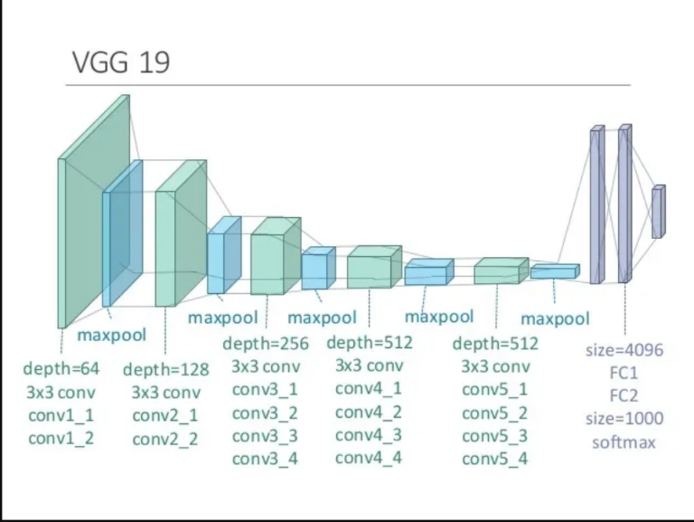

Algorithm:

Step1: input image with dimension x*y*z

Step 2: perform convolution with a kernel of 3*3 matrix and apply padding to the result image to have the same dimension as that of input image

Step 3: applying max pooling on the convolved output. Here the dimensions of the image keep reducing and because the relevant features are getting extracted

Step 4: applying convolution and max pooling in the alternate order 4 more times

Step 5: finally use SoftMax function to flatten up the data and enter the deep network for training and testing procedures

1. U-NET:

Architecture:

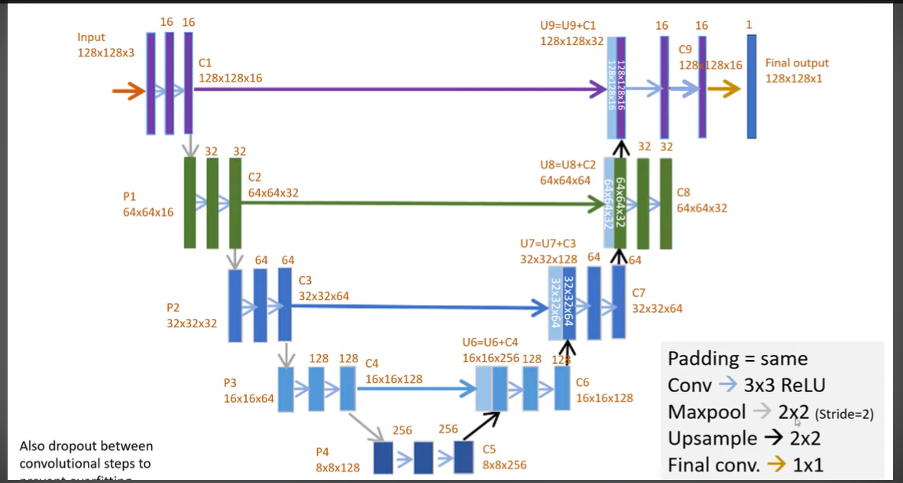

Algorithm:

Step 1: input image of dimension 128*128*3

Step 2: perform convolution with kernel of 3*3 matrix and apply padding to the result

Step 3: perform max pooling to the convolved result to deduce more relevant features and apply padding again

Step 4: keep repeating above 3 steps for 3 more iterations

Step 5: perform up sampling after the last convolution of down sampling.

Step 6: in the up sampling concatenate the previous results from the down sampling stage at every stage of up sampling. The number of stages of up sampling are same as the number of stages of down sampling

1. DENSE-NET:

Architecture:

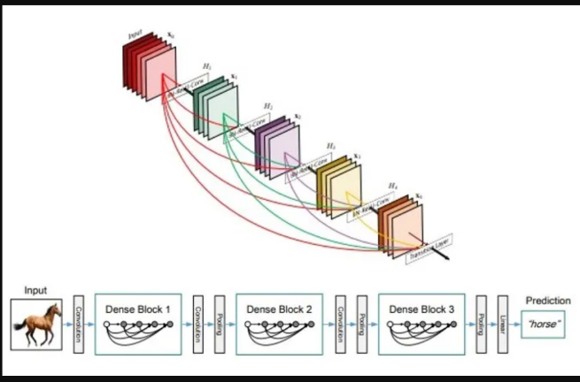 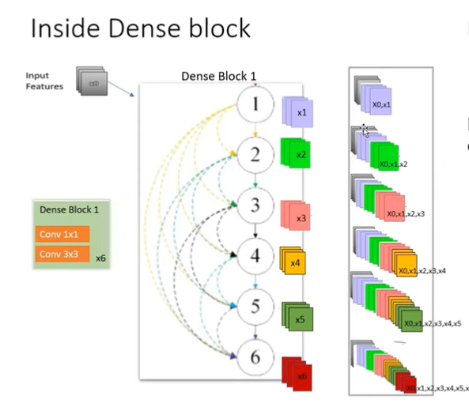

Algorithm:

Step1: input an image of x*y*z dimension

Step 2: convolution layer 1 is applied with kernel 7*7 and max pooling is applied with kernel 3*3

Step 3: enter the dense blocks. (There are 4 dense blocks each containing several layers of convolution). the first dense block has 6 layers of convolution

Step 4: inside a dense block: apply convolution (batch norm, ReLU, convolve (3*3), dropout) to the input and the output of this convolution becomes input to the next convolution layer in the same dense block

Keep this till all the convolution layers have been passed through

Step 5: perform convolution with kernel 1*1 and pooling with feature map 2*2 after coming out of the dense block. This is down sampling

Step 6: enter the next dense block. The input to the first layer in this block will be the output from the previous down sampled output. Continue step 4 process

Step 7: perform global pooling after passing through all the dense blocks

Step 8: perform SoftMax for flattening and finally enter the deep network for training and prediction

*Each layer of new features on top of already existing features.

*Concatenation of layers on top of each other could only be done if outputs are of same dimension

**IMPLEMENTATION AND RESULTS**

4.1 *implementation detail*

Execution

Data selection:

* Data was selected from ADNI which was downloaded in the form of NII files
* The first step was to convert the NII data into PNG format

Data preprocessing:

* Firstly, Data was visualized
* Image enhancement was used to eliminate all the noise and highlight the skull region for better Training
* Enhancements used:

1. Grey scaling
2. Median filtering
3. Histogram equalization
4. Laplacian filtering for enhancing edges

Model Selection:

* Using CNN models for training
* U-Net model along with training, segments the images as well
* VGG-16/VGG-19 forms a dense network of 16-19 hidden layers (not used yet)
* DENSE-NET (not used yet)

These models are apt for medical image data handling and hence selected

Model Implementation:

* Data is split into training and testing and then all the above models are applied
* Evaluation is done using testing data
* Data prediction is done based on the test data set
* Finally results from all the models is analyzed and further optimization techniques are Applied

Optimization Techniques:

* Using evolutionary computing and quantum optimization (work in progress)

4.2 *Result and Discussion*

a) **U-NET**:

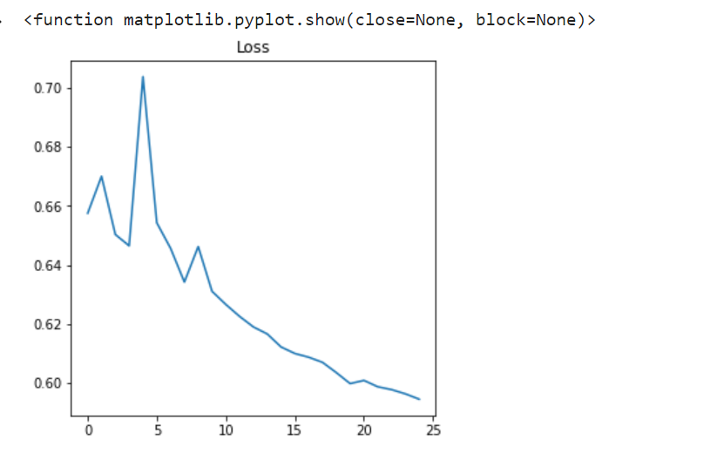fig 4.2.a1 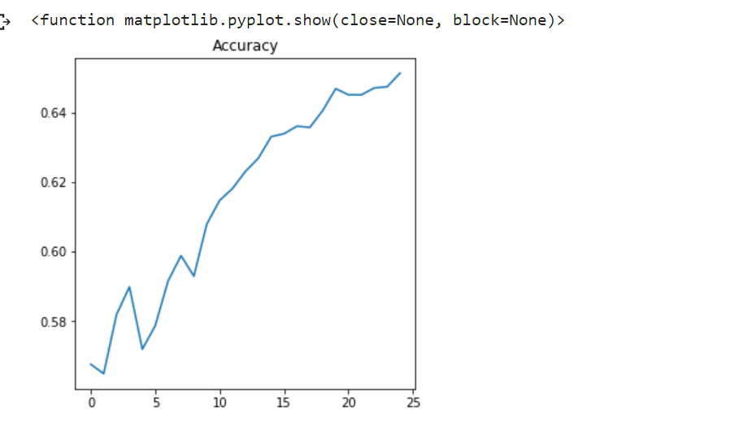 fig 4.2.a2

Table 1. Results of the U-NET Model

|  |  |  |  |  |  |  |
| --- | --- | --- | --- | --- | --- | --- |
| Model Name | Activation  Function/s | Loss function | Optimization  algorithm | epochs | Batch Size | Accuracy |
| U-NET | ReLU | Binary cross entropy | Adams | 25 | 16 | 65% |
|  |  |  |  |  |  |  |
|  |  |  |  |  |  |  |
|  |  |  |  |  |  |  |

b) **VGG-19**

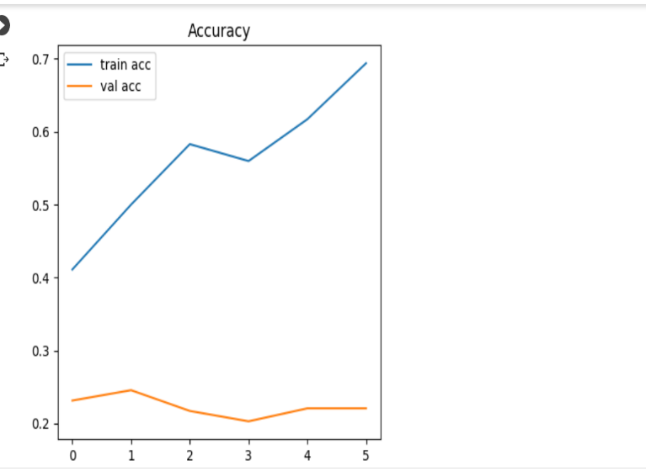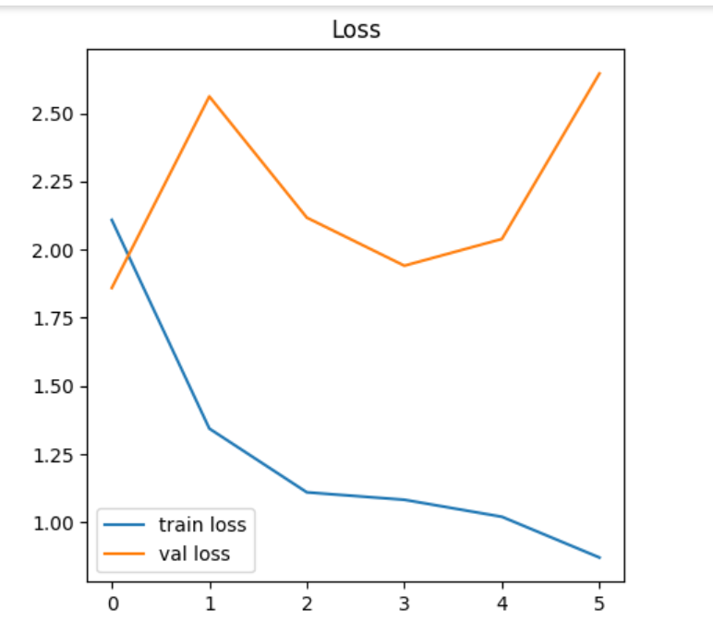

fig 4.2.b1 fig 4.2.b2

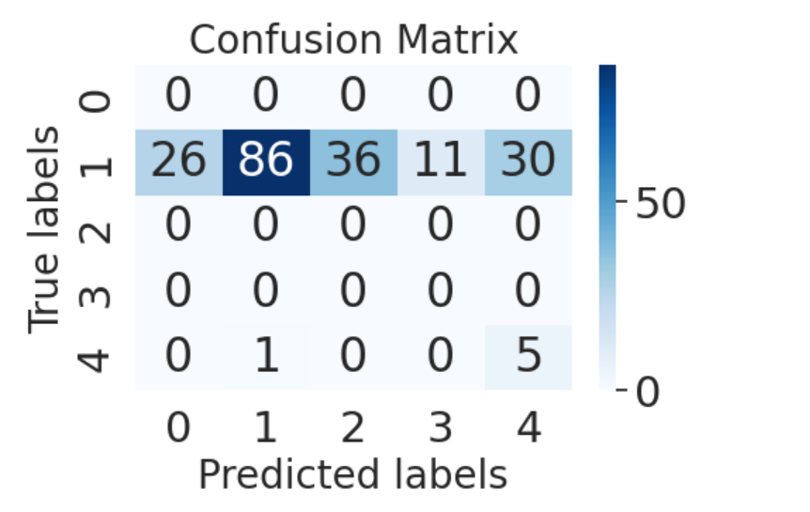

fig 4.2.b3

|  |  |  |  |  |  |  |
| --- | --- | --- | --- | --- | --- | --- |
| Model Name | Activation  Function/s | Loss function | Optimization Algorithm | epochs | Batch Size | Accuracy |
| VGG-19 | ReLU | Sparse categorical cross entropy | Adam | 10 | 30 | 70% |

Table 2. Results of the VGG-19 Model

|  |  |  |  |  |  |
| --- | --- | --- | --- | --- | --- |
|  |  |  |  |  |  |
|  |  |  |  |  |  |

**DENSE-NET:**

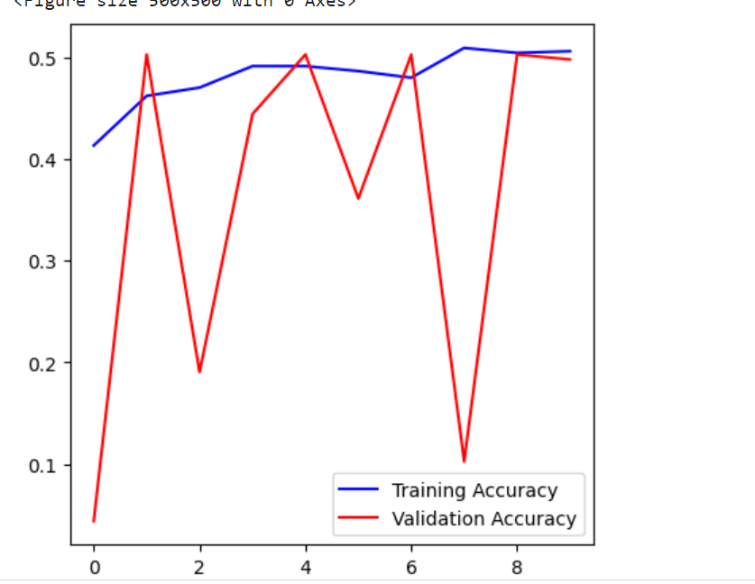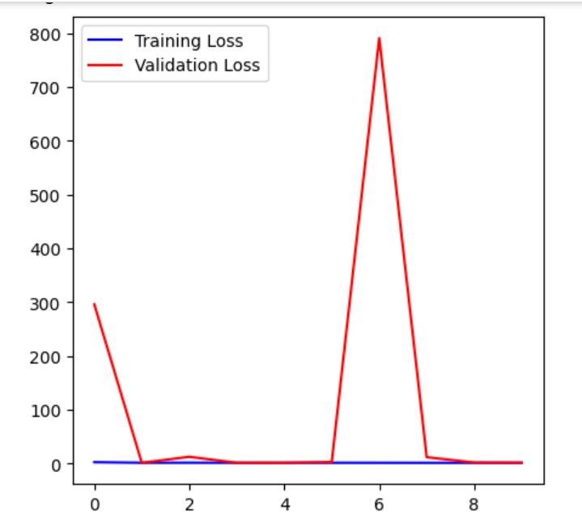

fig 4.2.c1 fig 4.2.c2

|  |  |  |  |  |  |  |
| --- | --- | --- | --- | --- | --- | --- |
| Model Name | Activation function/s | Loss function | Optimization algorithm | Epochs | Batch size | Accuracy |
| DENSE-NET | ReLU/SoftMax | Categorical cross entropy | Adam | 10 | 16 | 50% |

Table 3. Results of the DENSE-NET Model

4.3-*month wise progress (Gantt chart)*

|  |  |  |  |  |  |  |
| --- | --- | --- | --- | --- | --- | --- |
|  | **7th-19th Feb** | **20th Feb- 10th March** | **11th -20th March** | **21st-30th March** | **1st -14th April** | **15th-20th April** |
| **Dataset** |  |  |  |  |  |  |
| **Courses** |  |  |  |  |  |  |
| **Model Selection** |  |  |  |  |  |  |
| **Model Training** |  |  |  |  |  |  |
| **Presentation** |  |  |  |  |  |  |

**CONCLUSION AND FUTURE PLAN**

5.1 *Conclusion*

The U-Net model could only give an accuracy of 65%

Accuracy of VGG-19 model is 70% and Accuracy of DENSE-NET model is 50%

There could be many reasons for this some assumed:

* Data preprocessing could have been more effective for better accuracy
* Data rescaling if not done properly could give bad results so overall for a model to Perform better it is required to have an efficient data preprocessing
* Data splitting not done properly as input data is pixel value matrix and class labeled data That will be the output is categorical so converting it into binary and then matching with the dimensions of input image matrix could have been miscalculated

Improvement:

Better data processing

Applying other models to analyze and choose the one with better accuracy Then all other

Work in the final phase of the project is not done completely as that part requires more time, and the project was executed in only a 2-month' time. So, more work is left to be done in context of better accuracy and prediction results by combining optimization with training models. Once the better results are analyzed this work could be documented and the enhanced models could be used in field work

5.2 *Future Plans*

Most of the future ideas revolve around making the models better and effective for use

This includes applying novel ideas like that of combining deep learning with quantum optimization and evolutionary computing to extract maximum out of what is provided.

The rest of the work will include researching more on evolutionary computing and quantum optimization and applying the knowledge to the models

**REFERENCES**

***Journal / Conference Papers***

[1] Tayyaba Shahwar, j.Zafar,Ahmad S. Almorgan, “Automated Detection of Alzheimer’s via Hybrid Classical Quantum Neural Networks’’ February 2022, 12

[2] D.chitradevi, and S.prabha, alex Daniel Prabhu, “Diagnosis of LAzhimer disease in Mr brain images using optimization techniques”, 01 January 2021

[3] Josefa Diaz Alvarez, Jordi A. Matias Guiu, Maria Nieves Cabrera Martin, Vanesa Pytel, Ignacio Segovia-Rios, “Genetic Algorithms for Optimized Diagnosis of Alzheimer’s Disease and Frontotemporal Dementia Using Fluorodeoxyglucose Positron Emission Tomography Imaging, front. Aging neurosci.,” 03 February 2022

[4] Guangyao Chen, James Sargant, Sheridan Houghten, Tyler K. Collins, “Identification of Genes Associated with Alzheimer’s Disease using Evolutionary Computation”, 18th oct 2021, IEEE

[5] Nikola Kasabov, Reinhard Schleibs, Hiroshi Kojima, “Probabilistic Computational Neurogenetic Modelling: from Cognitive Systems to Alzheimer’s Disease”,20th June,2011

[6] Hadeer A. Helay, Mahmoud Badawy, Amira Y.Haikal, “Deep Learning approach for early Detection of Alzheimer’s Disease”, 03 Nov.2021